ASSIGNMENT 6

Alcohol test

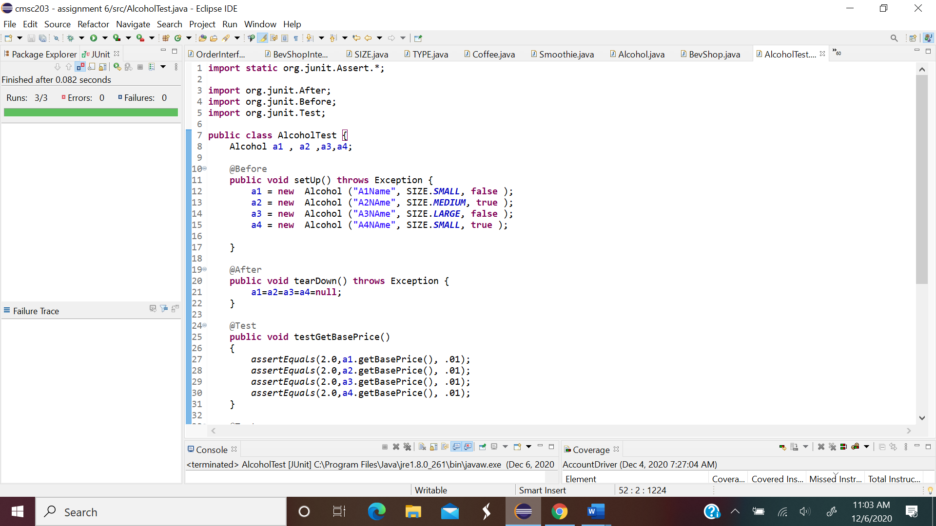

Coffee test 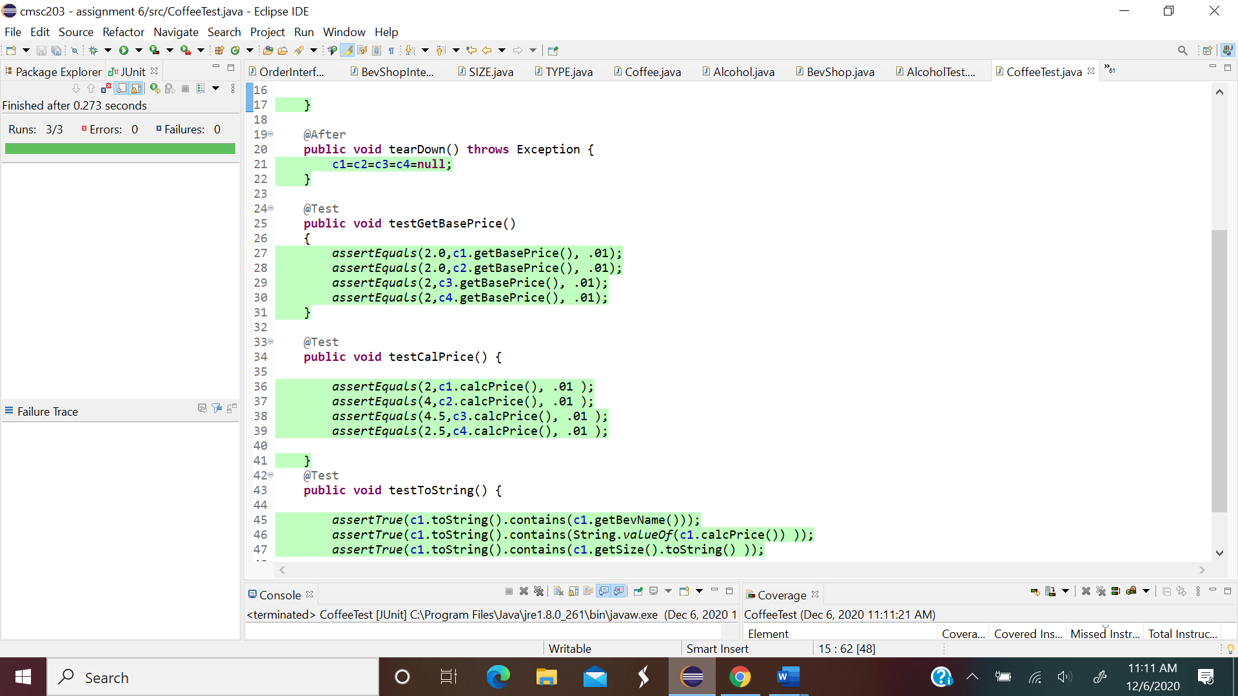

Customer test

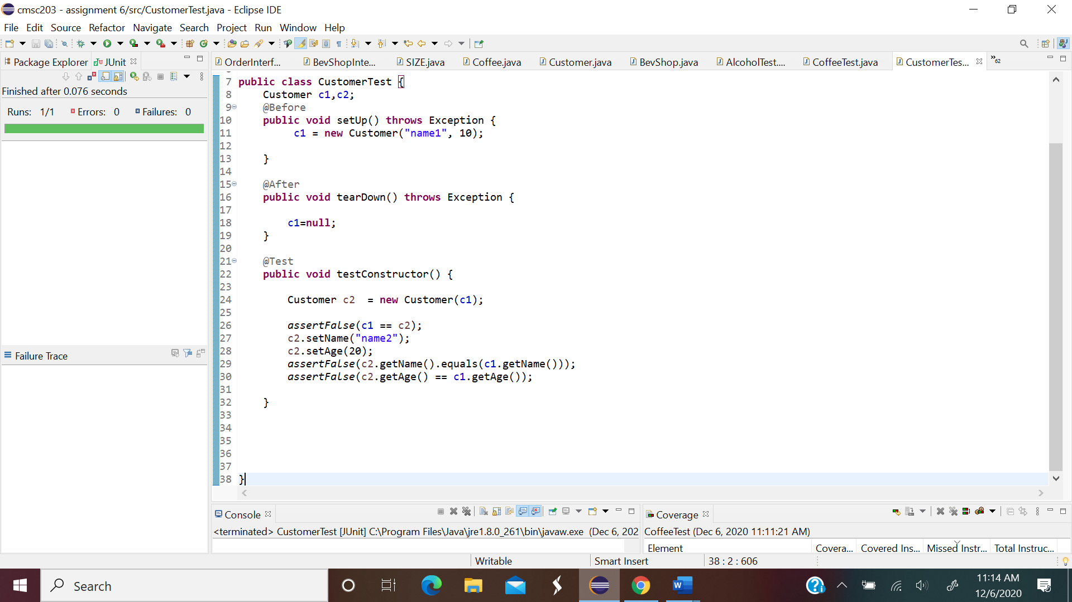

Order test

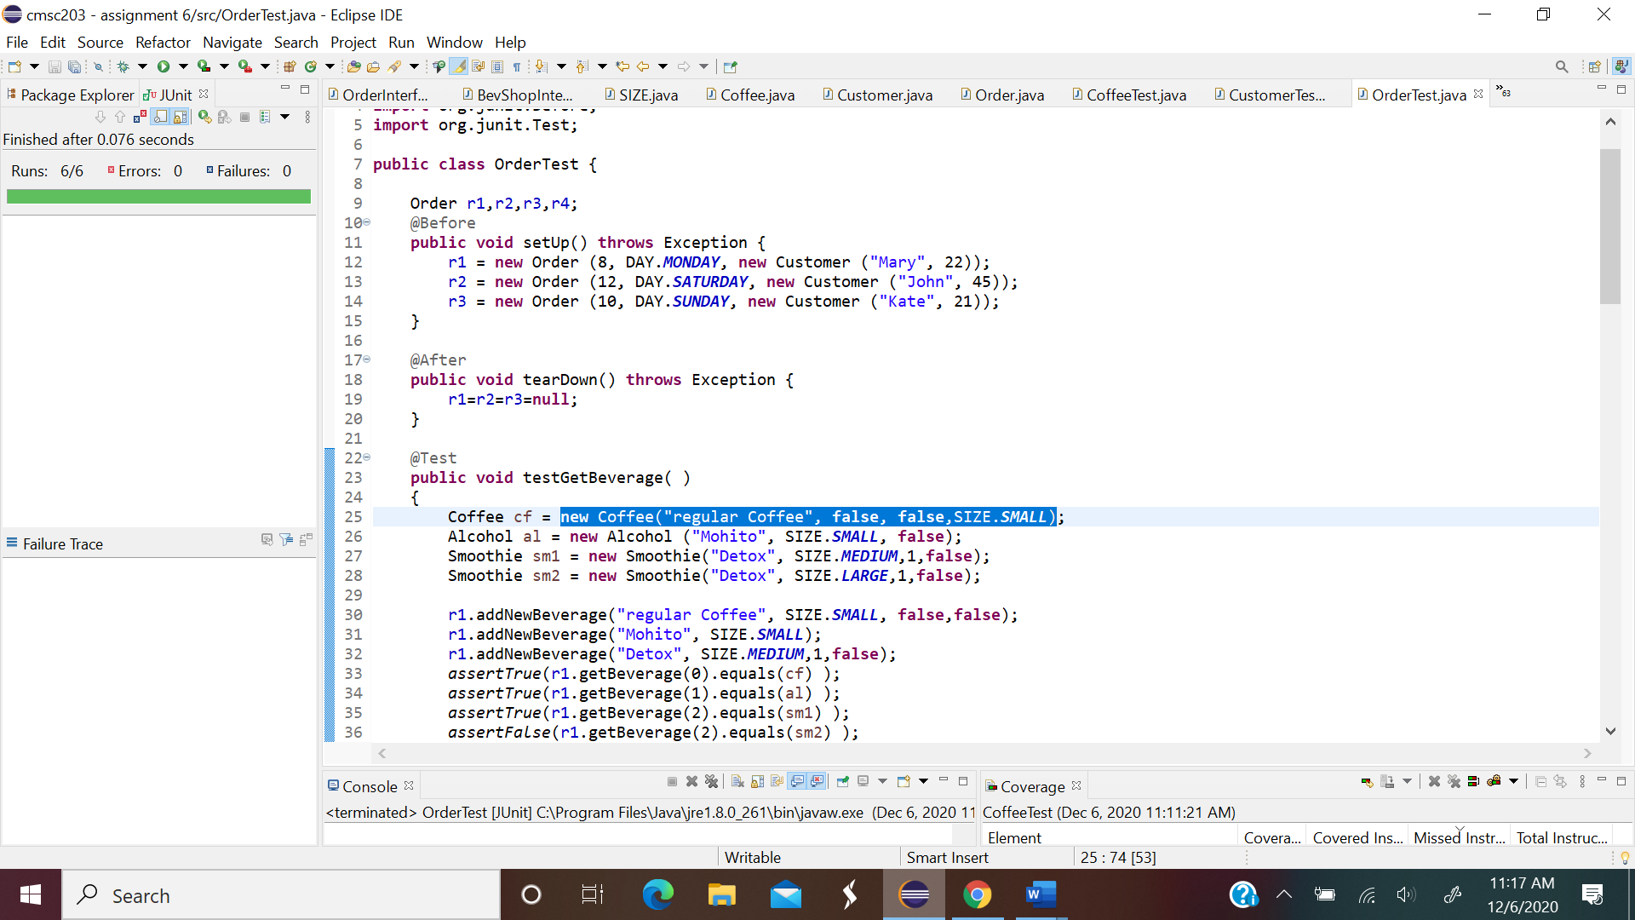

Smoothie test

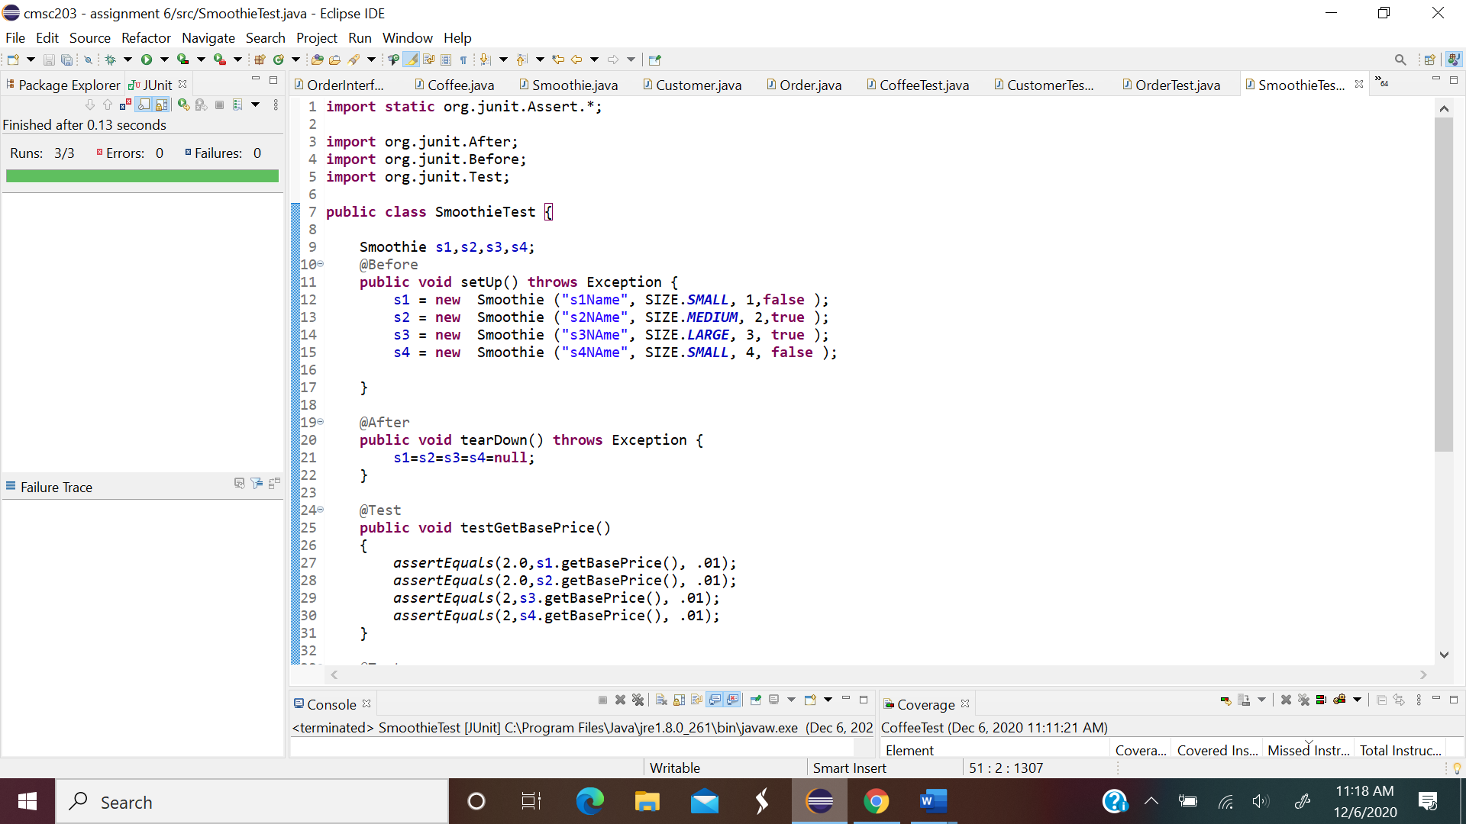

Screen shoot output

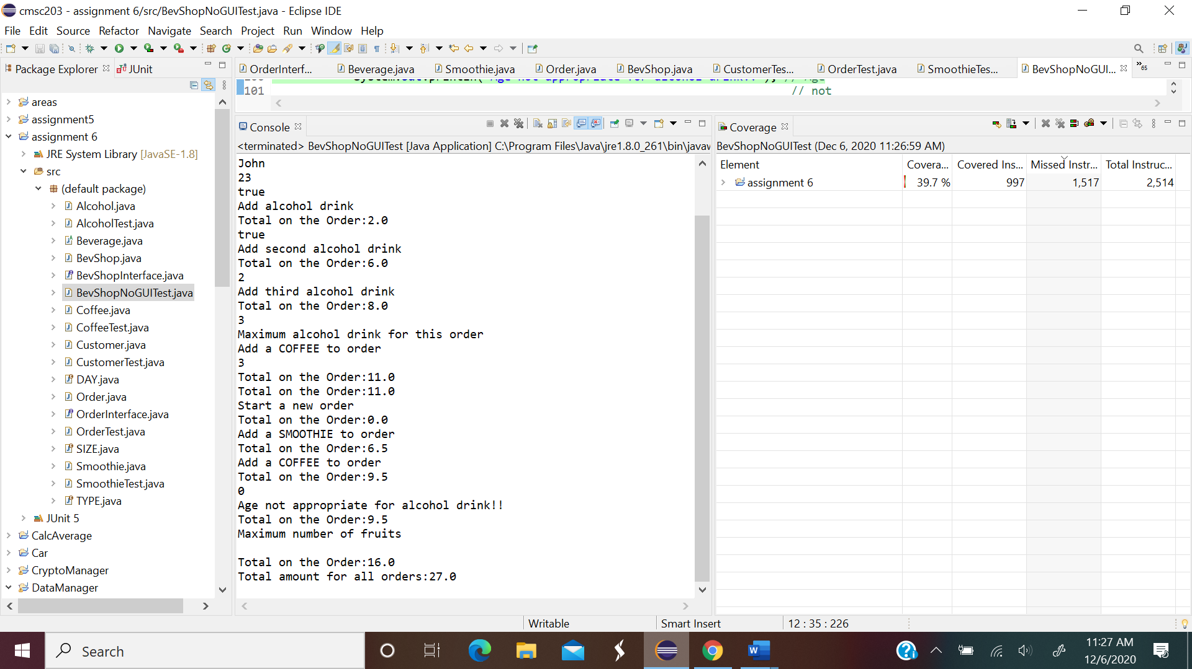

Scr java file

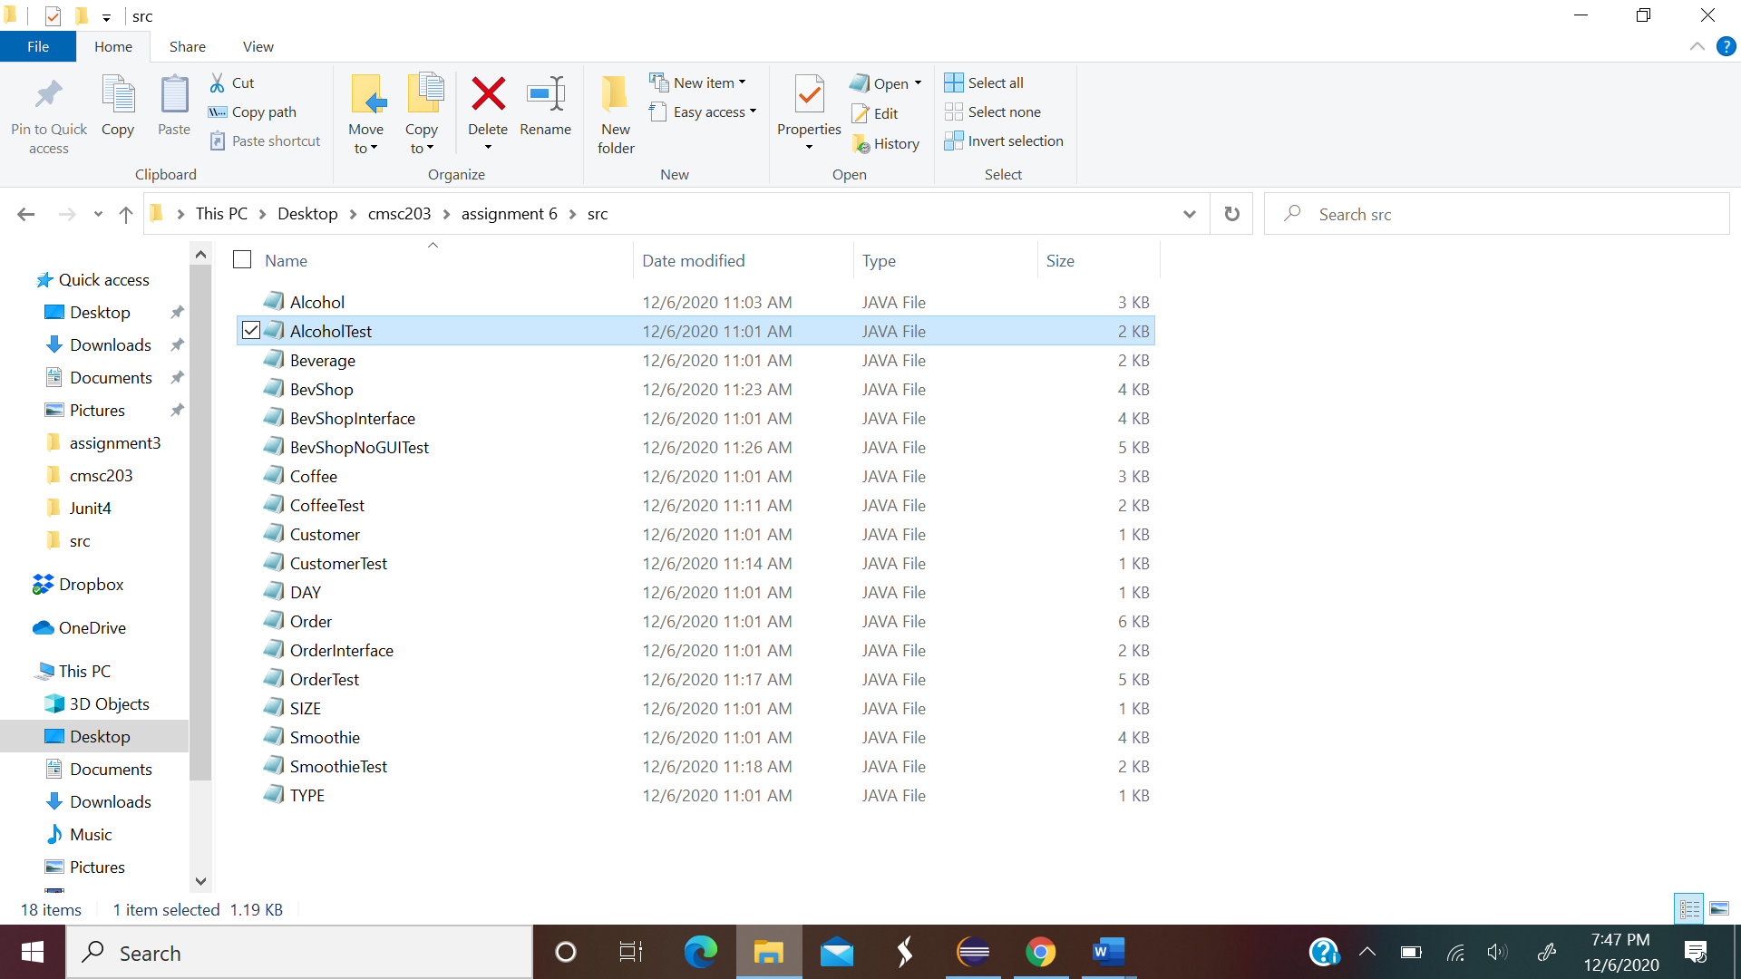

LESSON LEARN

This last assignment was very long and difficult. The best thing it resume almost everything we learned in this class. In this assignment ,I used interfaces, enumerated, overridden method. The only problem I encounter was testing my bevshop, the junit test failed, I do not know why. But everything seems right.

Iwould submit the UML diagram in separate sheet